Date: Monday, Nov 15, 2018 G.C.

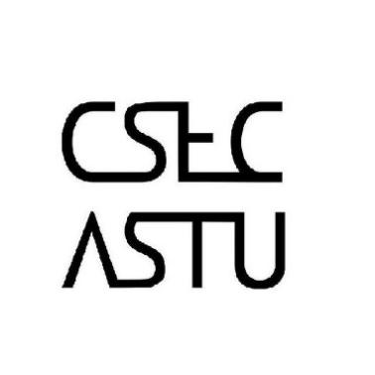

For all Students who registered last week to join

CSEC-ICPC, there will be an orientation regarding the entrance exam. Attendance is mandatory, it will familiarize you with the club’s activities and we will be collecting data on your primary/preferred programming language.

**Venue** – Cafe #1, right next to the lounge

**Orientation Time** – Friday Nov 16, 2018

11:30 Local Time

**Follow US on social Media for more updates…**

